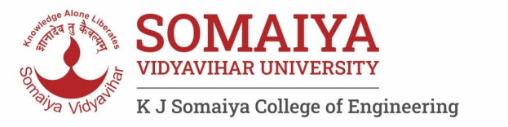

Year : 2020-
Department of Science and Humanities
Engineering Chemistry Laboratory

List of Experiments (2021- 22)

Sr. No. | Name of Experiments and link | CO Mapping
1 | To understand & familiarize with Good Laboratory Practices in Chemistry Laboratory | CO 1-5
2 | To understand the concept of pH indicator and to determine suitable indicator for acid-base titration. | CO-1
3 | To determine the hardness of water using EDTA titration. | CO-1
4. | To determine the chemical pollutants in water samples using advanced analytical techniques. | CO- 4
5 | Determine the viscosity average molecular weight of a polymer | CO-2
6 | To study the construction and working of compression molding. | CO-2
7 | To find out the unknown concentration of the sample and verification of Beer-Lambert's Law | CO-5
8 | To determine the available nitrogen in the soil sample by Kjeldahl Method | CO-3
9. | Interpretation of IR spectra | CO-5
10. | To measure the EMF of a cell and predict the spontaneity of the cell reaction | CO-3
11 | To determine the pH value of given solutions using pH meter. | CO-5
12 | To study the catalytic effect of finely divided particle | CO-4

Dr. Bharati Choudhari
Lab In-charge
Engineering Chemistry Laboratory

